PLEASE CHECK YOUR PROPERTY

Help Bring Tyler Wagaman Home
Tyler Wagaman and his black Ford F-150 have been missing since June 15, 2026. Despite extensive search efforts by law enforcement and volunteers, neither Tyler nor his vehicle has been located.
The FBI's Cellular Analysis Survey Team (CAST) has identified the highlighted area on the enclosed map as the priority search area and believes Tyler is within this area. Because your property is located within or near this search area, we are asking for just a few minutes of your time.

Please check:

- Barns, sheds, and outbuildings
- Fields and fence lines
- Wooded areas and trails
- Ravines and creek beds
- Hunting property
- ATV or logging roads
- Overgrown or brush-covered areas
- Drainages and culverts
- Abandoned structures
- Areas that are not visible from the road

Even if you've looked before, taking another look can make a difference. Changes in vegetation, lighting, or simply viewing the area from a different angle may reveal something that wasn't previously noticeable.
If you notice anything unusual—please report it. Even information that seems minor could help.
If you are able to check your property, we would greatly appreciate knowing that it has been searched. If you are unable to search your property yourself but would be willing to allow trained volunteers to search it, please let us know. We are happy to coordinate a search at a time that works for you.
You can submit an anonymous or named update at silverliningofhope.com/tyler-w or contact Megan directly at 317-867-5309 (texting is preferred).
Thank you for taking a few minutes to help bring Tyler home. Every property checked brings us one step closer to finding Tyler.

Tip Information
Johnson County Sheriff's Office: 317-346-6336
or: silverliningofhope.com/tyler-w

PLEASE CHECK YOUR PROPERTY

Help Bring ___________Home
(Case details) Tyler Wagaman and his black Ford F-150 have been missing since June 15, 2026. Despite extensive search efforts by law enforcement and volunteers, neither Tyler nor his vehicle has been located.
The FBI's Cellular Analysis Survey Team (CAST) has identified the highlighted area on the enclosed map as the priority search area and believes Tyler is within this area. Because your property is located within or near this search area, we are asking for just a few minutes of your time.

Please check:

- Barns, sheds, and outbuildings
- Fields and fence lines
- Wooded areas and trails
- Ravines and creek beds
- Hunting property
- ATV or logging roads
- Overgrown or brush-covered areas
- Drainages and culverts
- Abandoned structures
- Areas that are not visible from the road

Even if you've looked before, taking another look can make a difference. Changes in vegetation, lighting, or simply viewing the area from a different angle may reveal something that wasn't previously noticeable.
If you notice anything unusual—please report it. Even information that seems minor could help.
If you are able to check your property, we would greatly appreciate knowing that it has been searched. If you are unable to search your property yourself but would be willing to allow trained volunteers to search it, please let us know. We are happy to coordinate a search at a time that works for you.
(Online tip / update information) You can submit an anonymous or named update at silverliningofhope.com/tyler-w or contact Megan directly at 317-867-5309 (texting is preferred).
Thank you for taking a few minutes to help bring Tyler home. Every property checked brings us one step closer to finding Tyler.

Tip Information
Johnson County Sheriff's Office: 317-867-5309
or: silverliningofhope.com/tyler-w

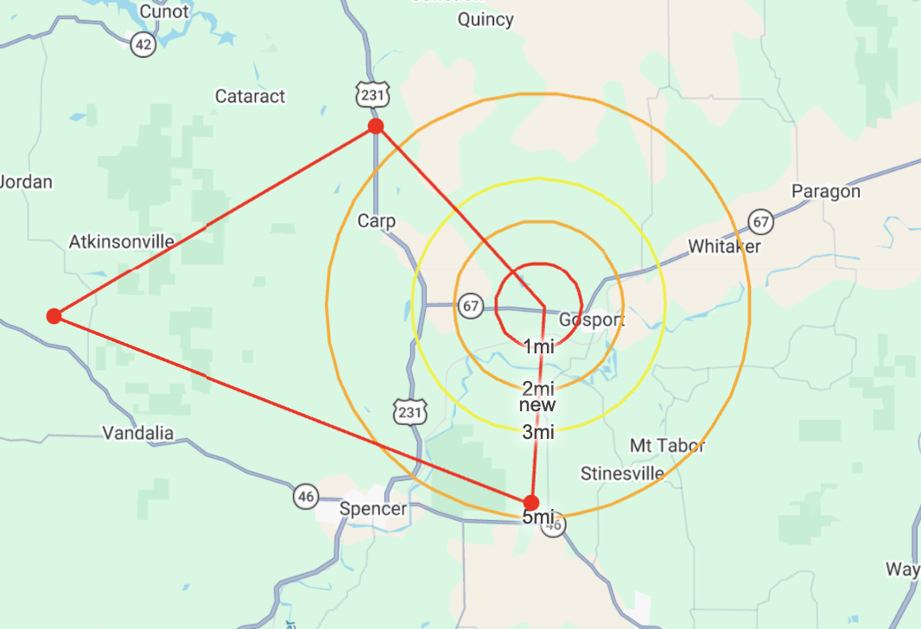
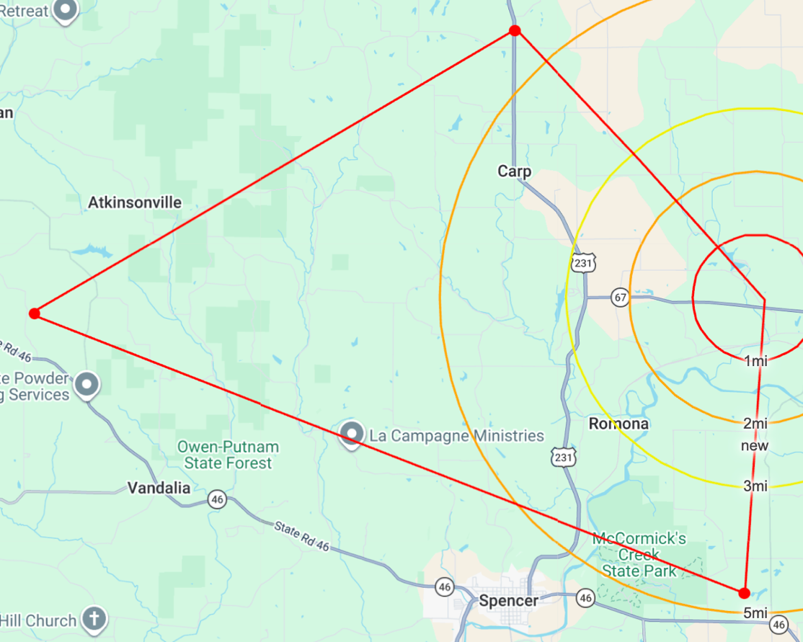
Inside of the red circle is the cell tower that Tylers phone pinged from. The large red polygon is the location that the FBI's Cellular Analysis Survey Team (CAST) has identified as the primary search area.

